Apply to Join the
Global Advocacy Team on
Community-led Development Planning

What is the Global Advocacy Team?

The Global Advocacy Team initiative brings together incredible community activists from around the world to conduct community-led research and mobilize communities to strengthen local campaigns and collectively change development policy. To do this, the Global Advocacy Team reinforces existing local campaigns with community-led data and identifies their own development priorities. Based on real-life experiences, the Global Advocacy Team presents formal policy recommendations for how real development should be designed, funded and implemented. The next iteration of the Global Advocacy Team will train 8 community organizers from around the world to organize and create their own community-led development plans. For more detailed information please refer to the concept note.

The Global Advocacy Team initiative is led by an Advisory Group and the International Accountability Project (IAP). The Advisory Group members are six prominent activists from Latin America and the Caribbean, Southeast Asia, South Asia, and Africa, who will advise and support the initiative. Read more about the Advisory Group.

Apply now to be one of 8 community organizers who will form the 2021-2023 Global Advocacy Team!

Why community-led development planning?
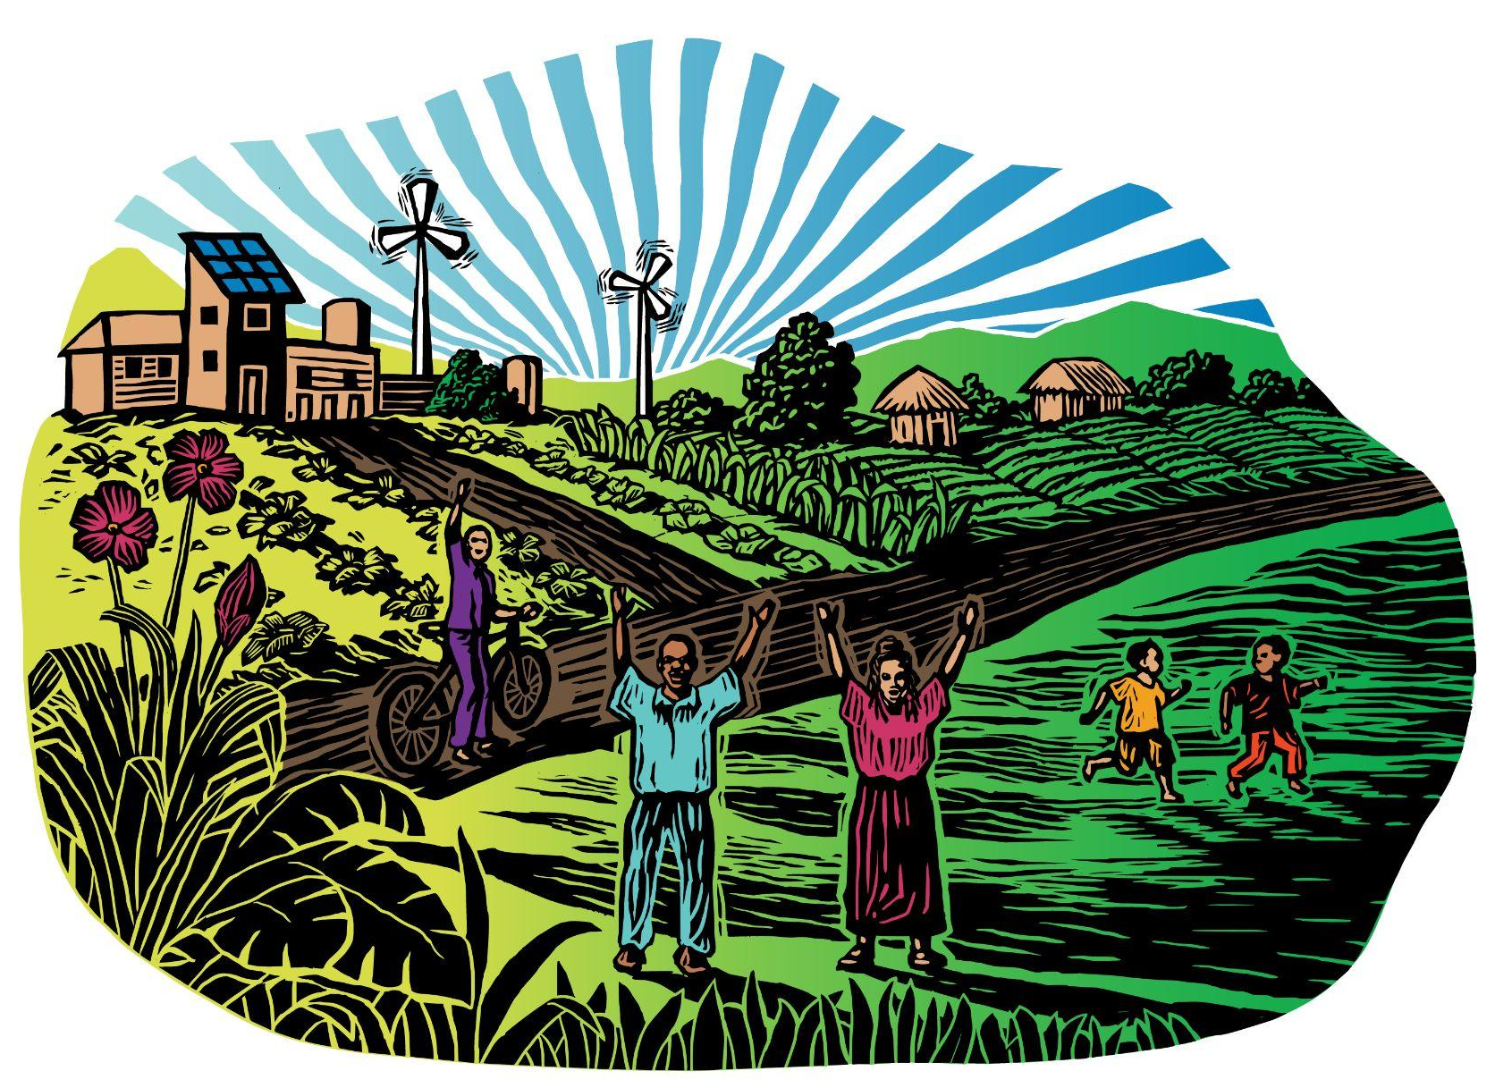
As IAP and our partners have witnessed again and again, those designing, implementing and
financing today’s “development”, still fails to meaningfully involve the people whose lives, homes, livelihoods and environment are most impacted. These so-called development projects repeatedly cause harm and often leave communities worse off than before. To that effect, in 2015 IAP convened the first Global Advocacy Team to document community-level expertise and challenge the existing narrative of development that violates rights with community-led research and recommendations.

For development to be inclusive and participatory, communities must be recognized as experts and leaders. The Global Advocacy Team initiative believes communities have the knowledge and expertise to determine their own development priorities. Therefore, the Global Advocacy Team initiative will focus on understanding the needs of the community and provide them the opportunity to have their own plan and solutions.

A community-led development plan determines or strengthens a community’s own development priorities and improves their participation in decision-making which affects their lives and livelihood.

Who can become GAT members?

We are looking for 8 community organizers from all over the world. As members or representatives of a community, the Global Advocacy Team will have a demonstrated commitment to organize and create community-led development plans and an openness to learn from each other’s experience and expertise.

- Members will be either from a community or have strong and mutually acknowledged relationships with communities.

- Everyone on the Team will have the passion and experience advocating for development that respects human and environmental rights.

- Each Team member will be committed to act as a leader and active collaborator.

- Being a part of this Global Advocacy Team must benefit the goals of each Team member’s community or organization.

GAT program details:

Members of the Global Advocacy Team will complete the following activities, during a year-long program:
- Work closely with Global Advocacy Team members to develop a participatory action research project for a community-led development plan, involving community networks and partners;
- Participate in regular online and in person meetings and trainings together with IAP staff and the Advisory Group;

- Actively participate in all campaign activities, including leading organizing and campaigning activities in their home country;
- Have the possibility to travel for their research and learning of community-led research;

- Participate in one-on-one and group mentoring and exchange of experience with the Advisory Group and IAP team;

- Draft a community-led development plan as a conclusion of the community-led research and discussions conducted by Global Advocacy Team members with the local community;

- Together with other Global Advocacy Team members and communities, identify advocacy opportunities to encourage development actors to integrate community-led development planning models more widely;

- Review the community-led research results and individual development plans collectively with the Global Advocacy Team members and share insights, advice and recommendations in a published report.
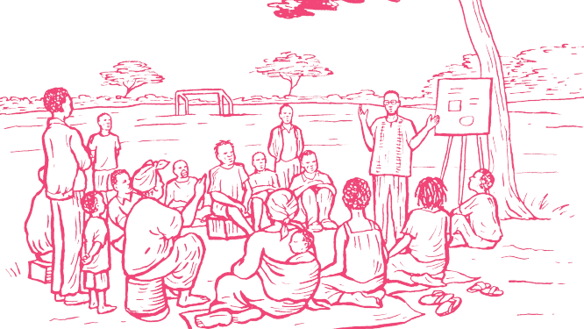

Support:

The initiative will provide the following support to each Global Advocacy Team member:

- Access to resources, expertises and capacity building support for conducting community-led research and creating a community-led development plan;

- Advice and training to identify the research topic, methodology, tools for data collection;

- Support the design and publication of the research and advocacy campaign;

- Technical support to organise workshops and online trainings;

- A small grant up to 5,000 USD for carrying out the community-led research including for activities, participatory action research, surveys, meetings, reporting back and determining recommendations;

- Cover necessary travel expenses related to the initiative —including expenses for visas, transport, airfare, food and accommodations.

Requirements & Criteria:

The following criteria has been identified for our 2021-2023 Global Advocacy Team:

- Applications will be accepted from individual community organizers or groups from a community, collective or civil society organization. All applicants must either be members of a community or have a close solidarity relationship with a community.

- Experience and passion for community-led development, human and environmental rights and for changing the current development process;

- Members’ experience should demonstrate commitment and leadership on these issues; Experience in, or strong interest in, leading community-led research and community organising and creating community led development plans;

- Members can use their native language throughout as the Global Advocacy Team initiative can provide translation and interpretation support throughout the program;

- Strong links between member’s current work at the community level and the work of the Global Advocacy Team. In other words, being part of the Team should benefit the work and goals of members’ home organizations, networks and communities;

- Candidates from underrepresented and marginalized groups and women will be prioritized.

Timeframe:

Application Due Date: November 10, 2021
Selection Process: Team members will be selected in November 2021
Announcement of Successful Candidates: December 2021
Program Duration: January 2022 to 2023

Application Process:

To apply to be a member of the Global Advocacy Team, please send your completed application with a letter of support from the group, organization or community you work with or plan to work with.

Apply online

https://bit.ly/GATgoogleform_ENG

The online application is available in Arabic, English, French, Russian and Spanish.

Apply by email
Complete the application below and email it, with the letter of support, to gat@accountabilityproject.org.

Please contact us if you plan to submit an application in another language.

For any questions about the application, alternatives for secured communication channels or to seek help addressing some questions in the application form, please contact gat@ accountabilityproject.org.

APPLICATION FORM
Global Advocacy Team

​​1. Are you applying as an individual? What is your name and the name of the community, collective or civil society organization you work with?
2. Are you applying as an entire community, collective or civil society organization? What is its name and the name of the contact person?
3. Country and city/village:
4. Languages spoken:
5. Phone:
6. Email:
7. Social Media or Website (if any):

8. Please describe your main activities and the aims of your group. What are some key activities you have done with the community in relation to the environment? Please provide related links and documents if available. (300 words only)

9. What problems or threats to the community would you like to understand better or document? (300 words only)

10. What actions must be taken to ensure equal participation of all groups within the community including women, youth, differently-abled people, religious minorities and marginalized groups? (300 words only)

11. What are the visions and dreams of the community? If you were part of a process to determine these, please explain your role. (400 words only)

12. Why are you interested in being part of the Global Advocacy Team? If you participate in the Global Advocacy Team, how will this experience benefit the community, organizations and networks you work with? (300 words only)

13. What are the 3 main organizations, groups or networks you are a part of?

14. Please provide a letter of support from the group, organization or community you work with or plan to work with. You may submit the letter by email to gat@accountabilityproject.org

